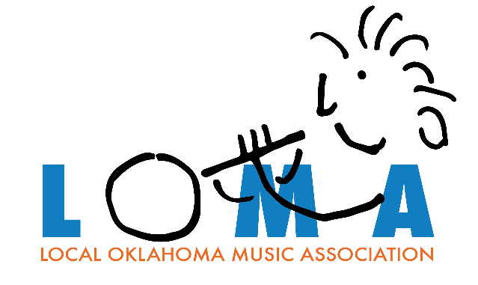

**LOMA Ticket Receipt & Agreement**

1. It is understood that the funds you raise with ticket sales from the LOMA fundraiser will be used solely for the purchase of instruments, instrument repair, print & electronic music, student fees and supplemental teachers or clinicians.
2. Your ticket sales can run for as long as you want and as many times as you want between the September 1, 2025, opening sales date and the February 28, 2026, closing date.
3. Ticket stubs and the money raised can be turned in at any time and as many times during the sales period as you want. When LOMA receives sold ticket stubs and money, LOMA will write a check to your organization for 100% of the money that you raised and turned in at that time. All ticket stubs, money raised and unsold tickets must be turned in by February 28, 2026.
4. It is understood that the school’s program is not responsible for ticket stubs and money that a student might lose but the school’s program will make every effort to return all sold ticket stubs.
5. The individual signing and receiving tickets acknowledges that they have read and understand the “Win $25,000 Cash” fundraiser rules posted on LOMA’s website.

____________________________________ ______________________ ____________________

School & Program Ticket Numbers Quantity

_____________________________________ ______________________ _____________________

Signature Title Date Received